***AUTOMATION WITH ULTRASONIC SENSOR***

***CIRCUIT:***

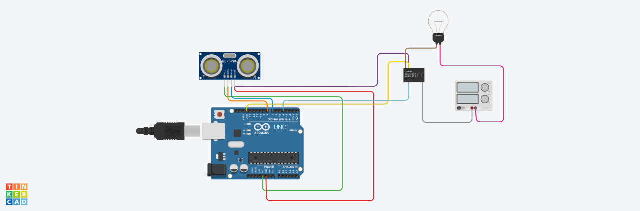

***CODE:***

#include <LiquidCrystal.h>

LiquidCrystal lcd = LiquidCrystal(10,9,8,7,6,5); // Create an LCD object. Parameters: (RS, E, D4, D5, D6, D7):

const int trigPin = 12;

const int echoPin = 11;

float time, distance;

void setup()

{

lcd.begin(16, 2); // Specify the LCD's number of columns and rows. Change to (20, 4) for a 20x4 LCD

pinMode(trigPin, OUTPUT);

pinMode(echoPin, INPUT);

Serial.begin(9600);

}

void loop()

{

digitalWrite(trigPin, LOW);

delayMicroseconds(2);

digitalWrite(trigPin, HIGH);

delayMicroseconds(10);

digitalWrite(trigPin, LOW);

time = pulseIn(echoPin, HIGH);

distance = (time*.0343)/2;

// For Serial Monitor

Serial.print("Distance:CM ");

Serial.println(distance);

// For LCD Display

lcd.setCursor(0,0);

lcd.print("Distance in CM");

lcd.setCursor(0,1);

lcd.print(distance);

}